Sow parity, body length, postural changes and piglet crushing

Mario Ostović^{1,}, Željko Pavičić¹, … and Boris Antunović⁴

¹Department of Animal Hygiene, Behaviour and Welfare, Faculty of Veterinary Medicine, University of Zagreb, Zagreb, Croatia
…
⁴Department of Animal Husbandry, Faculty of Agriculture, J. J. Strossmayer University, Osijek, Croatia

Introduction
Farrowing crates are the most common type of accommodation for lactating sows and their litters in intensive production. The system was developed in the 1960s to reduce the high rate of piglet mortality, to rationalize room utilization, and to reduce the need for care and the cost of pig breeding⁵. However, in spite of using farrowing crates, the rate of piglet mortality due to crushing by the sow has continued to contribute significantly to the overall piglet mortality as a major economic and animal welfare problem. Farrowing crate dimensions are generally based on the sow’s static spatial requirements, including room for physical body accommodation, whereas dynamic spatial needs, including adequate room for body posture changes without obstruction by the crate, are mostly disregarded. Alongside this drawback, the increase in sow body size with increasing parity⁴ poses an additional problem, since sows are eliminated from production after their 4th and 5th parity on average in intensive pig breeding¹. In the present study the correlation between sow parity, body length, the number of body posture changes and the number of crushed piglets was observed.

Materials and Methods
The study was carried out at a pig farm farrowing unit during an average 27-day production cycle and included 76 Seghers hybrid sows divided into three groups: parity 1 (n = 25), parity 3 (n = 27) and parity 5 (n = 24). The mean (± SD) number of piglets born alive per sow was 10.45 ± 1.23. Each sow was accommodated with the litter in a farrowing crate of the same dimensions, with a partially slatted concrete floor. The length of the crate was 1.80 m, the width of the parallel bars for the sow 0.56 m, and the width of the crate accessible by the piglets 0.35 m and 0.75 m. The length of sow body was determined by use of a measuring tape upon their accommodation in the farrowing crates. The frequency of sow posture changes was recorded on days 1, 10 and 20 of lactation. Ten sows were randomly chosen from each group and their postural behavior was recorded by digital video cameras for 4 hours (from 9.00 a.m. to 1.00 p.m.). Postural changes, as described elsewhere³, were recorded by analysis of camera images. Piglet death due to crushing was diagnosed by postmortem analysis. Statistical analysis was performed by use of Statistica v. 13.4 software. Normality of data distribution was verified by the Kolmogorov-Smirnov test. The significance of differences in the study parameters among the three groups of sows was determined by analysis of variance. Correlation between parameters was determined by linear correlation for the parameters with normal distribution (sow body length and postural changes), while Spearman Rank Order correlation was employed for the number of crushed piglets.

Results
The study results are shown in Table 1 and Figure 1. The sow body length increased with parity (P<0.001) and a high positive correlation between the sow parity and body length was recorded (P<0.05). The rate of sow posture change decreased with parity and increased with the time of lactation. On all days of lactation observed a high negative correlation was determined between the number of sow posture changes and parity, whereas between the number of sow posture changes and body length there was a significant to high negative correlation (P<0.05 all). Between the number of crushed piglets and other investigated parameters no significant correlation was found.

Table 1. Sow body length and number of crushed piglets according to parity
Parity | Sow body length (cm)  Mean ± SD | Crushed piglets (n)  Median (min - max)
1 (n = 25) | 121.18* ± 3.80 | 0 (0 - 2)
3 (n = 27) | 134.82* ± 4.02 | 0 (0 - 2)
5 (n = 24) | 141.97* ± 2.33 | 1 (0 - 2)
*Values in the same column are significantly different (P<0.001)

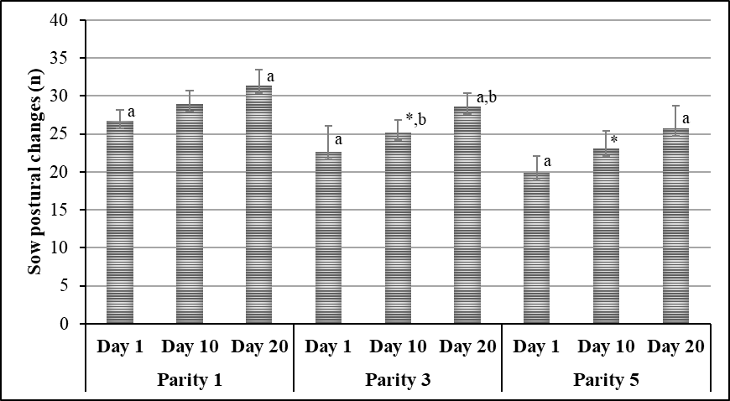

Fig. 1. Frequency of sow postural changes in a 4-hour period on lactation days 1, 10 and 20 according to parity
Values are expressed as Mean ± SD; n = 10 sows per group; all values on the same lactation days are significantly different (P<0.05), with the exception of those marked with asterisk*; ^{a, b} values within the parity marked with the same letter in a superscript are significantly different (P<0.05)

Discussion and Conclusions
Increasing body length in multiparity sows results in lower frequency of postural changes but does not influence the rate of piglet crushing. However, since in commercial production both parity 1 and multiparity sows are housed in farrowing crates of the same dimensions, this husbandry practice could be detrimental for their comfort. Namely, frequent postural changes as well as reduced postural changes may both reflect a lack of comfort in the sows². Therefore, sow parity should also be taken in consideration when designing farrowing crates to accommodate the size of the sows and make them more comfortable.

References
1. AKOS, K., G. BILKEI (2004): Comparison of the reproductive performance of sows kept outdoors in Croatia with that of sows kept indoors. Livest. Prod. Sci. 85, 293-298.
2. ANIL, L., S. S. ANIL, J. DEEN, S. K. BAIDOO (2006): Cortisol, behavioral responses, and injury scores of sows housed in gestation stalls. J. Swine Health Prod. 14, 196-201.
3. GÖTZ, M. (1991): Changes in nursing and suckling behaviour of sows and their piglets in farrowing crates. Appl. Anim. Behav. Sci. 31, 271-275.
4. McGLONE, J. J., B. VINES, A. C. RUDINE, P. DUBOIS (2004): The physical size of gestating sows. J. Anim. Sci. 82, 2421-2427.
5. PUPPE, B., M.-C. MEUNIER-SALAÜN, W. OTTEN, P. ORGEUR (2008): The welfare of piglets. In: Welfare of Pigs: from Birth to Slaughter. (Faucitano, L., A. L. Schaefer, Eds.), Wageningen Academic Publishers, The Netherlands & Éditions Quæ, Versailles, France, pp. 97-132.

Corresponding author: mostovic@vef.hr

